**EXPERIMENT NO- 04**

**AIM**: Building a switch – based network / Configuration of Cisco Catalyst Switch 3560

**OBJECTIVE**: To demonstrate building a switch – based network / Configuration Cisco Catalyst Switch3560.

**ALGORITHM:**

1. Start

2. Setup the Topology and initialize devices

3. Configure Devices and verify connectivity

4. Display Device information

5. End

**DESCRIPTION AND EXECUTION:**

Resources: 1 Switch, 2 PCs, 1 Router.

The devices are connected in a star topology:

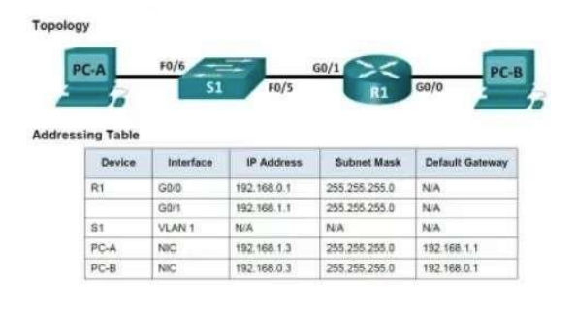

Laying out required devices & connecting the devices using cables:

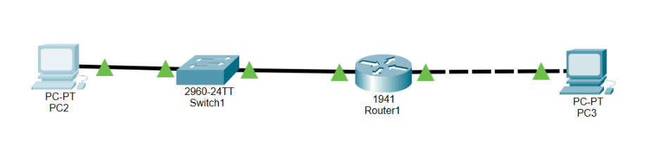

Configuring PC-A and PC-B:

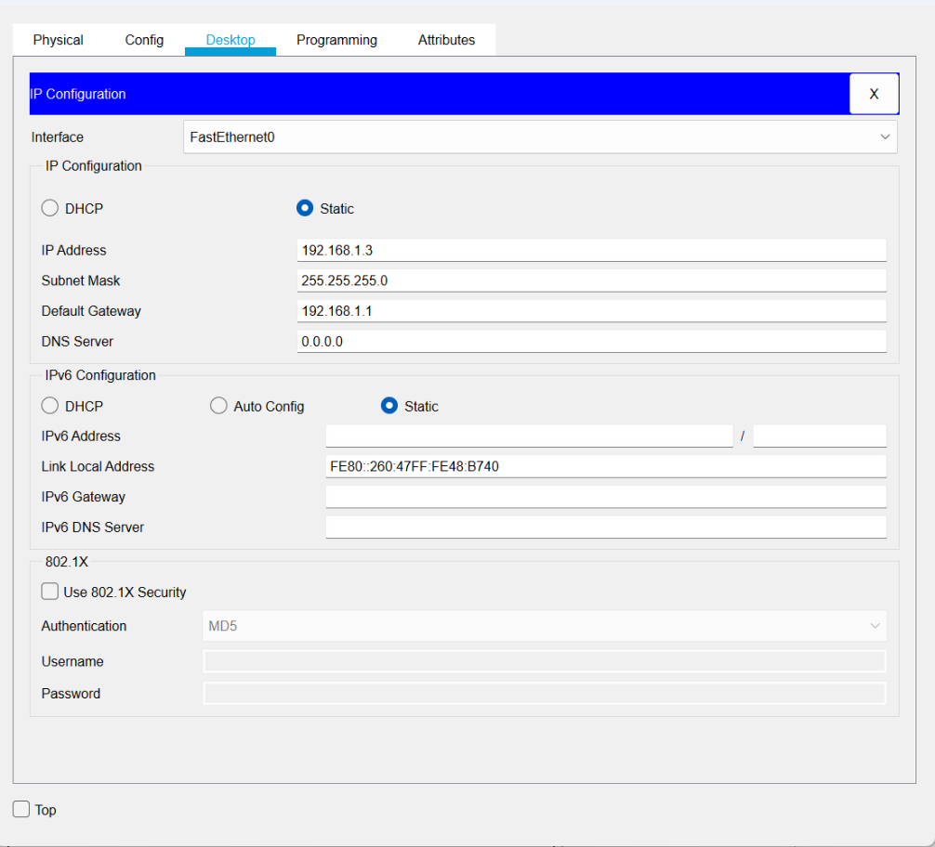

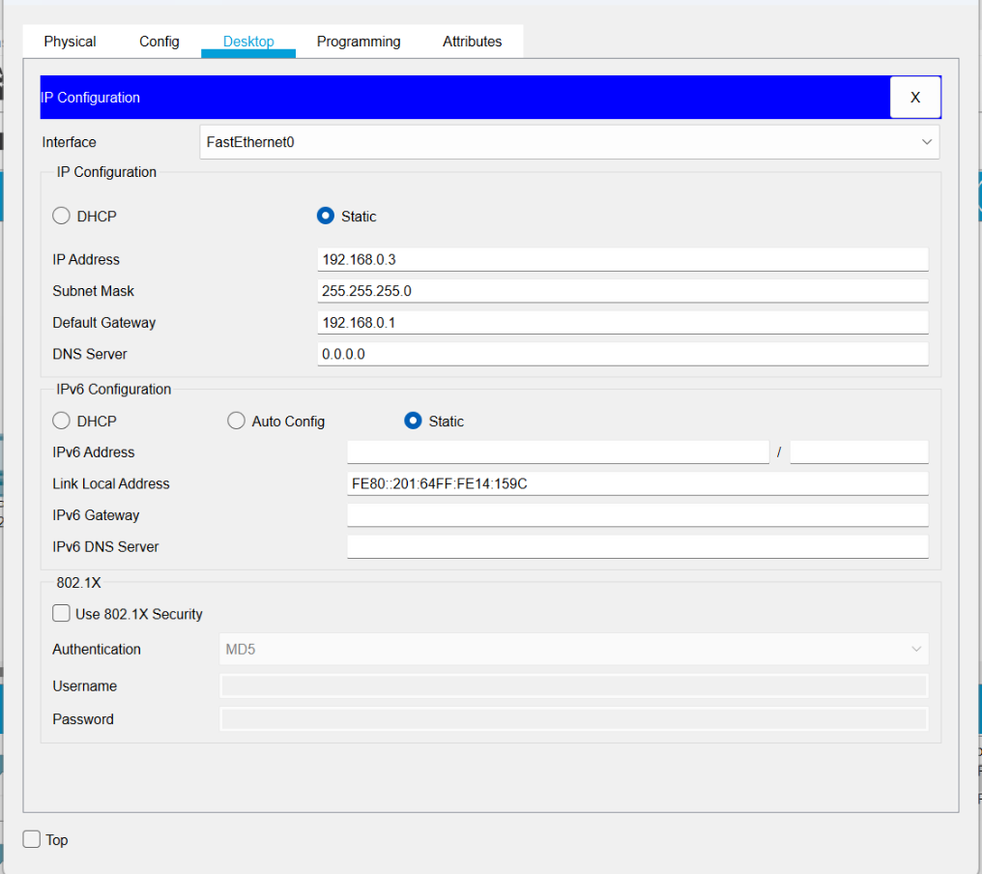

Configuring Switch S1:

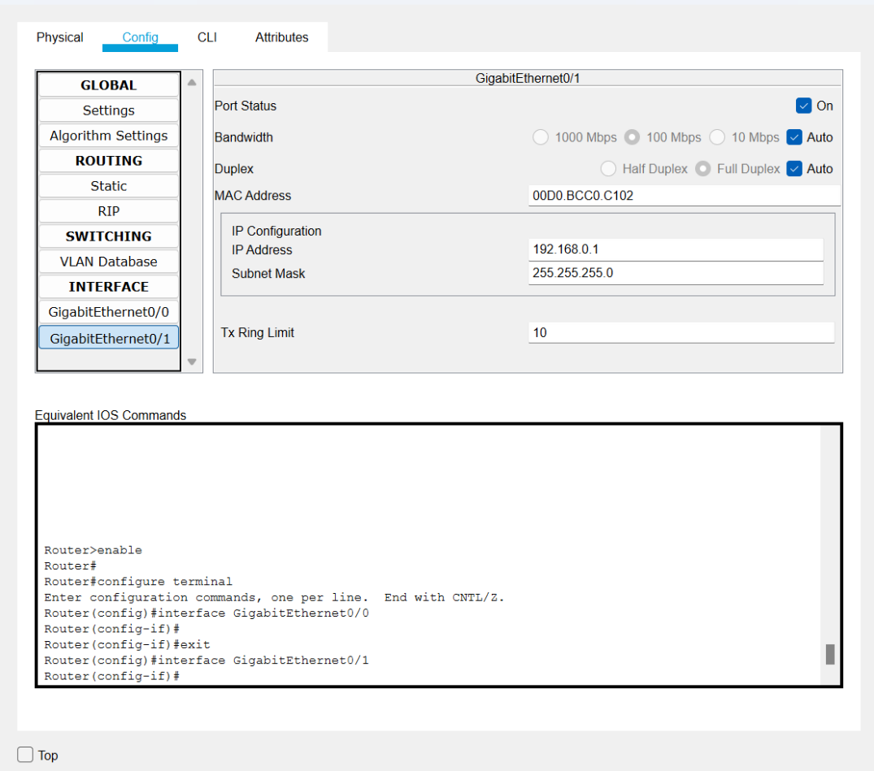

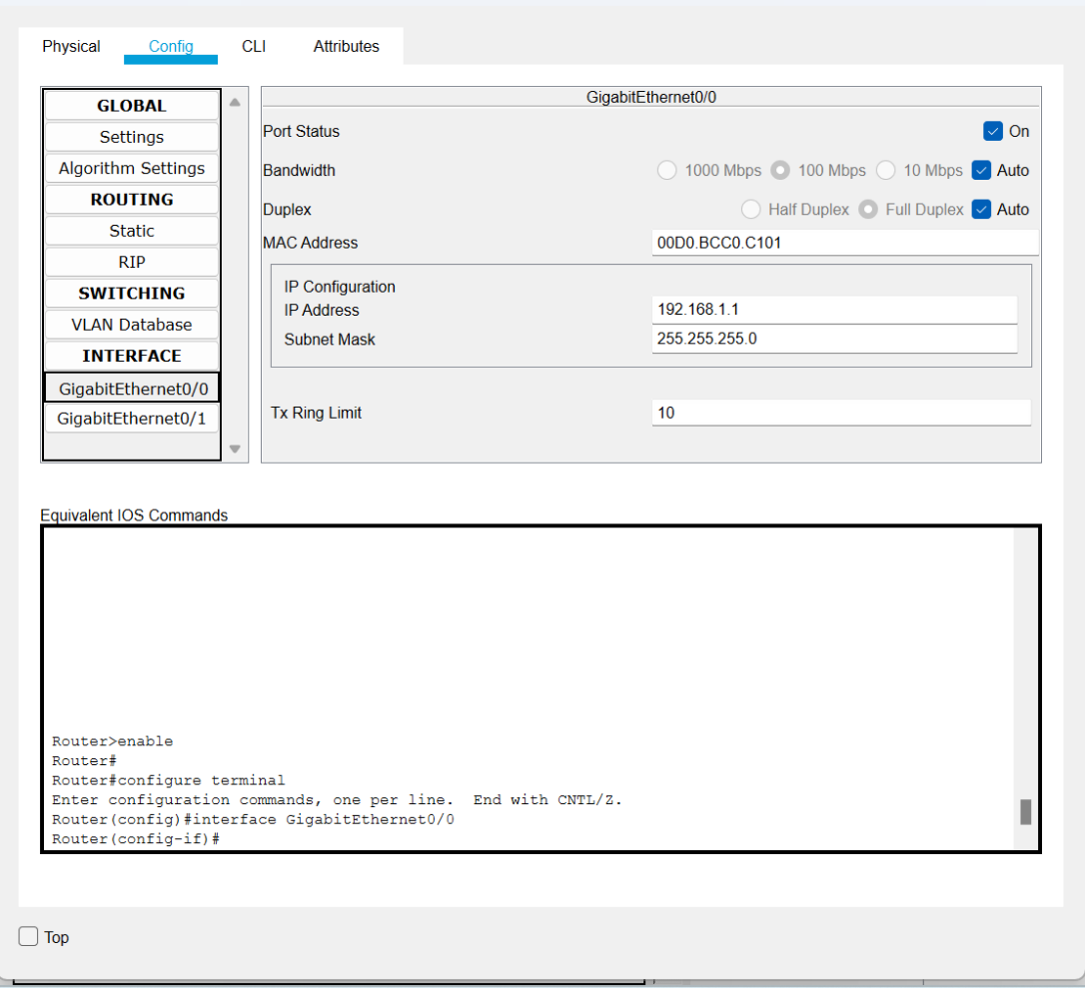

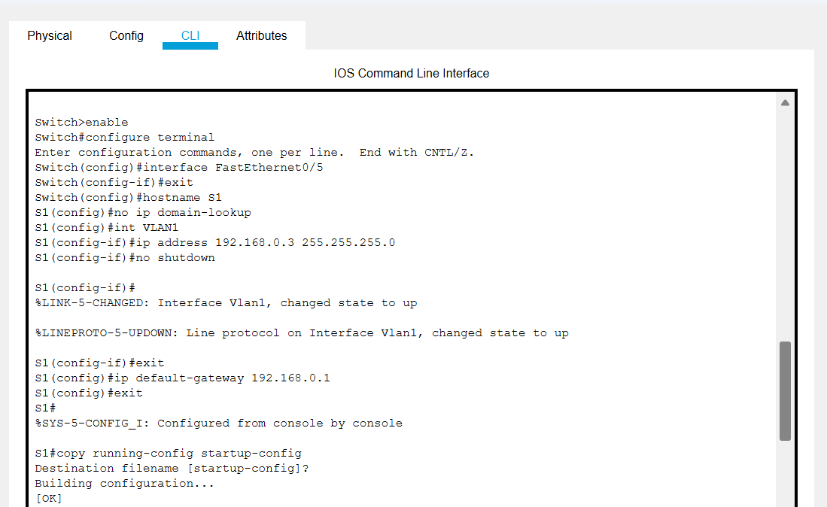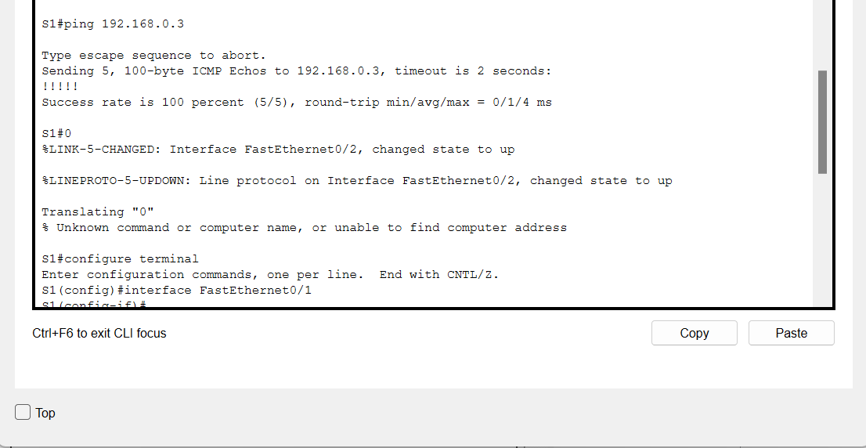

Checking ping from PC-A to PC-B:

`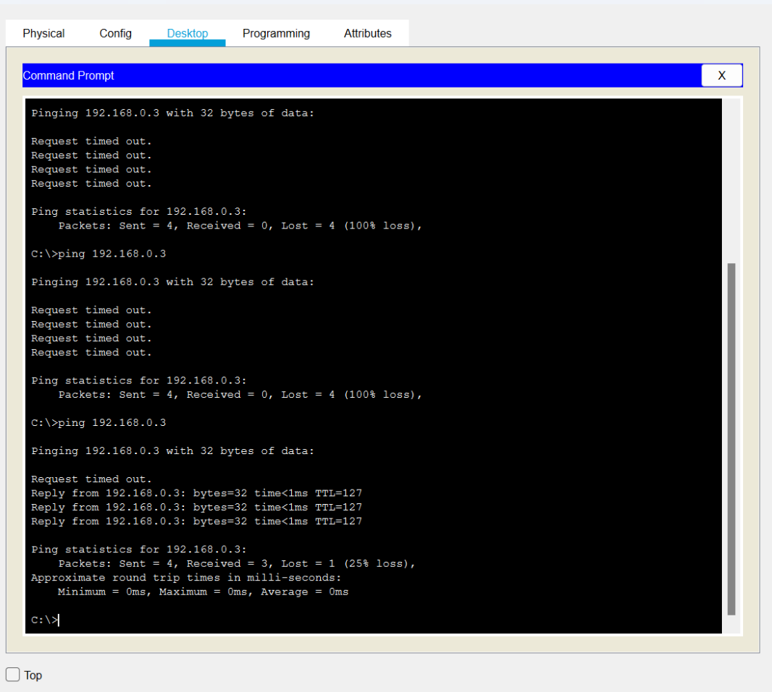

RESULTS: After the configuration and connection of all devices, the ping is successful from PC-A to PC-B.